# SQL Server 2014 Licensing

### <https://www.faceofit.com/sql-server-2014-licensing/>

SQL Server 2014 Licensing has become complex over the years, especially when Microsoft decided to move from CPU Socket based licensing to CPU Core based Licensing with SQL 2012 onward.

***The current version of SQL Server is SQL 2014, with SQL 2016 to be released shortly.***

So, lets talk about SQL 2014 and its Licensing methodology.

Currently, we have the SQL Server versions:

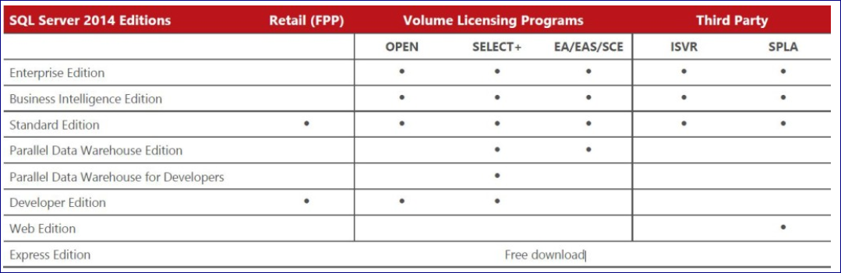

***SQL Server Express Edition is a free Re-Distributable package. Which means, you can distribute this package as many times as you want, without the need to buy any license. It’s a Free Download!***

***SQL Server Web Edition is a special edition of SQL Server only available to Web Hosting companies under a SPLA License.***

***Parallel Data Warehouse Edition comes bundled with a Database Appliance with comes pre-loaded directly from the vendor. (Dell, HP or EMC).***

So keeping these options aside, let us focus on the Core versions of SQL Server which would be the choice for the majority of you.

They are,

* **SQL Server Standard Edition.**
* **SQL Server Business Intelligence Edition.**
* **SQL Server Developer Edition.**
* **SQL Server Enterprise Edition.**

**SQL Server Standard Edition:** This is the only edition which can be bought under [**Server/User** or **Server/Device CAL**](https://www.faceofit.com/sql-server-2014-server-cal-licensing/) (Client Access License) based Licensing as well as [**CPU Core based Licenses**.](https://www.faceofit.com/sql-server-2014-core-licensing/)

You can buy Standard Edition under Retail, Volume Licensing (Open, Select+ EA/EAS/SCE) or Third Party (ISVR & SPLA).

**SQL Server Business Intelligence Edition:**This edition of SQL Server is ***only available under the***[***Server/CAL and Server/Device model***](https://www.faceofit.com/sql-server-2014-server-cal-licensing/). [Core based licensing](https://www.faceofit.com/sql-server-2014-core-licensing/) is not available for this edition of SQL Server. This version of SQL Server is there for End to End BI deployments, using SSIS (ETL), SSAS (CUBE) SSRS (Reporting) and a relational Database.

***Note: SQL Server Analysis Services Tabular Edition is not available with this version.***

This version is available through all channels except for Retail, i.e. Volume Licensing (Open, Select+ EA/EAS/SCE) or Third Party (ISVR & SPLA).

**SQL Server Developer Edition:** This edition of SQL Server is only available per Developer per Organisation. This can only be used in Development, User acceptance (UAT) and Testing purposes. You cannot use this license for production under any circumstances. It costs roughly 50$ per Developer.

***MSDN subscription is a good alternative to this method of Licensing SQL Server during Dev & Test phases.***

Developer Edition is only available in Retail and Volume Licensing (Open & Select+)

**SQL Server Enterprise Edition:**This is the highest version of SQL Server, which contains all the features SQL Server has to offer. This includes BI features, Relational Database & SharePoint 2010/2013 integration features.

Only available in [Core based Licensing](https://www.faceofit.com/sql-server-2014-core-licensing/). Like the BI edition, Enterprise Edition (EE) is available through all channels except for Retail, i.e. Volume Licensing (Open, Select+ EA/EAS/SCE) or Third Party (ISVR & SPLA).

Next, we will discuss how to better understand [Core Based Licensing](https://www.faceofit.com/sql-server-2014-core-licensing/) and other FAQ’s.

# How To License SQL Server 2014 : Core Licensing

<https://www.faceofit.com/sql-server-2014-core-licensing/>

Microsoft **SQL Server 2014 Core Licensing** method is the one that majority of the Medium to Large Enterprises would go for. This is because of the fact that it gives you ***unlimited client connections***. There is also no need for clients to purchase additional Client licenses (CALS). However, [as explained in my previous post](https://www.faceofit.com/sql-server-2014-server-cal-licensing/), the Server CAL model of licensing is beneficial for smaller deployments with “Fixed” limited client connections. If you are new to SQL Server Licensing, [**please see this post first**](https://www.faceofit.com/sql-server-2014-licensing/).

## SQL Server 2014 Core Licensing

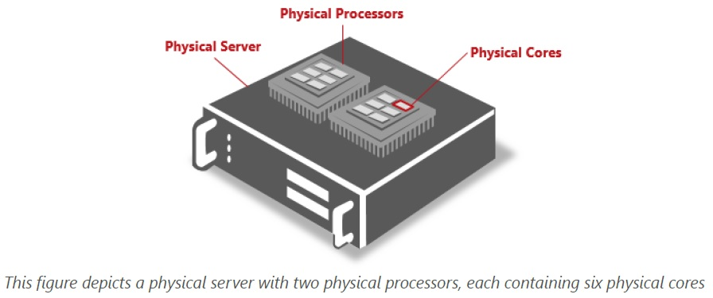

*Source: Microsoft Licensing Guide for SQL 2014*

Now, here is when things can get a bit more complex. Imagine the picture above, and understand the following terms which would be used to understand Core-Based licensing.

* **Physical Server** – The Server ([Which is not a Virtual Machine](https://www.faceofit.com/sql-server-licensing-in-a-vm/)) on which you plan to install SQL Server 2014.
* **Physical Processor** – Please refer to the picture above. Physical processors typically come from Intel & AMD. They look like this:

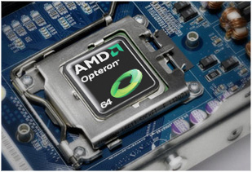

*source: AMD.com*

* **Physical Core**: Processors can contain **Dual**, **Quad**, **Hex**, **Octa** or more cores in each processor. It depends on the processor model or vendor.
* **Hardware Threads**: Logical threads introduced first with Intel Hyper-Threading Technology(HTT). AMD also sells Modules instead of Cores which adds a bit to the confusion.

You need to License all the physical cores of the Server. The exception here being [Virtual Machines](https://www.faceofit.com/sql-server-licensing-in-a-vm/).

***SQL Server 2008 R2 was the last release to come with “Per Socket Licensing”***

Here is what the official documentation says:

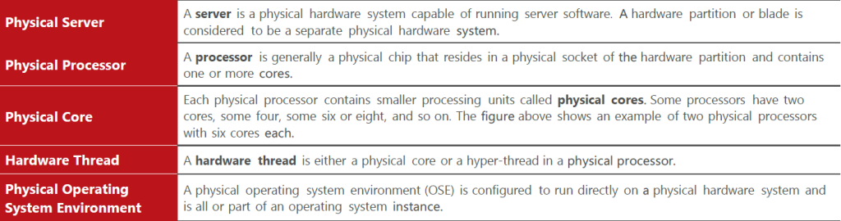

*Source: Microsoft Licensing Guide for SQL 2014*

Now, here are some of the points to remember:

* **All physical cores on the server must be licensed (**[**Exceptions being a Virtual Machine**](https://www.faceofit.com/sql-server-licensing-in-a-vm/)**)**
* **You need to buy a minimum number of licenses for each physical processor on the server, which is 4 cores.**
* **Core Licenses are sold in an even number of packs, i.e. 2 pack, 4 pack, 6 packs etc.**

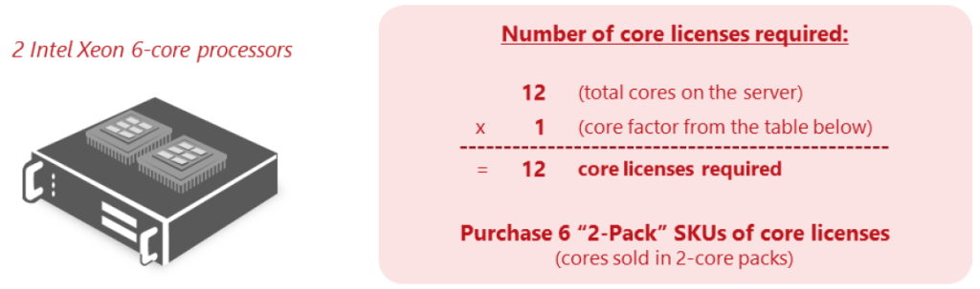

*Source: Microsoft Licensing Guide for SQL 2014*

To understand and calculate the Core factor, refer to the following table:

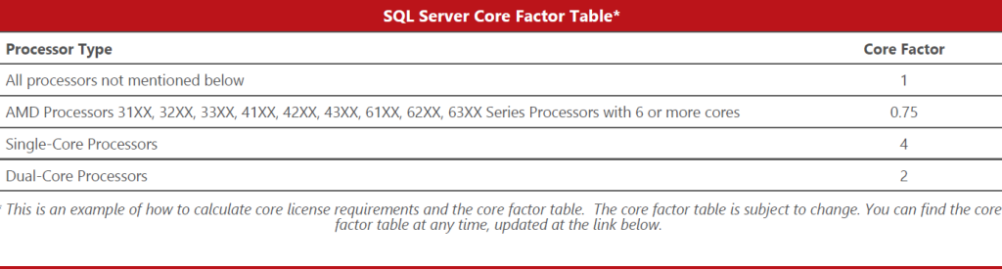

*Source: Microsoft Licensing Guide for SQL 2014*

### **Core-Based Licensing Considerations:**

* If you are buying **SQL Server Enterprise Edition**.
* When a Web-facing App is connecting to your SQL Server, the **only option** is to go for SQL Server Core-Based Licensing. This is because you will never be able to calculate the exact number of client connections which is connecting directly or indirectly to your SQL Server.
* When you have a large number of direct and/or indirect users/devices, Core based licensing is cheaper than [User/Device CAL based licensing](https://www.faceofit.com/sql-server-2014-server-cal-licensing/).

***Note: If you are using Intel based processors with hyper-threading technology enabled, it does not affect the number of core licenses required when running SQL Server software in a physical environment.***

In my next Article, I will discuss Licensing SQL Server in a [Virtual Environment](https://www.faceofit.com/sql-server-licensing-in-a-vm/).

If you have suggestions or questions, please drop us a comment below in the comment section.

Affiliate Disclosure: Faceofit.com is a participant in the Amazon Services LLC Associates Program. As an Amazon Associate we earn from qualifying purchases.

# SQL Server 2014 Licensing: Server & CAL Licensing

<https://www.faceofit.com/sql-server-2014-server-cal-licensing/>

In this post, we will focus on **SQL Server 2014 Licensing: Server & CAL Licensing**. Read along to know more:

### SQL Server 2014 Licensing: Server & CAL Licensing

In this post, we will only focus on the versions which would be purchased by most customers, i.e. **Enterprise**, **Standard** or **Business** **Intelligence** Edition. For these editions, SQL Server comes with two types of Licensing Models:

* Server/CAL based licensing
* Core-based Licensing

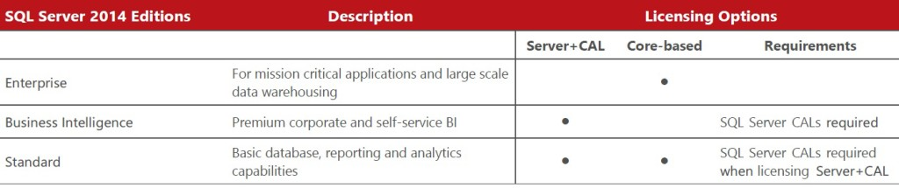

Server Cal Model of SQL Server

***Only SQL Server Standard Edition is available in both Server/CAL as well as Core Licensing.***

So, let us understand a bit more about the SQL Server Server/CAL Licensing models.  When licensing SQL Server software under the Server+CAL model, customers purchase a server license for each server, and a client access license (CAL) “OR” for a device (Device CAL).

A user needs to have a CAL’s to (User or Device CAL) access SQL Server or any of its components. A CAL is not software, it is a license granting users and devices access to the SQL Server software.

***Client Access Licenses are “Paper Licenses” and are not technically enforced. Which means that, in an event of an audit, the customer needs to prove that they have the required licenses of SQL Server for all its Users or devices.***

This method of Licensing is more cost effective than the CORE model, but the break even point is 15-20 users Per CPU (depending upon the SQL Server version)

***Do note that SQL Server does not give you “Concurrent Licensing” model. So all users and clients (Application, Apps, Server Administrators etc.) who are directly or indirectly connecting to the SQL Server needs to have a valid license.***

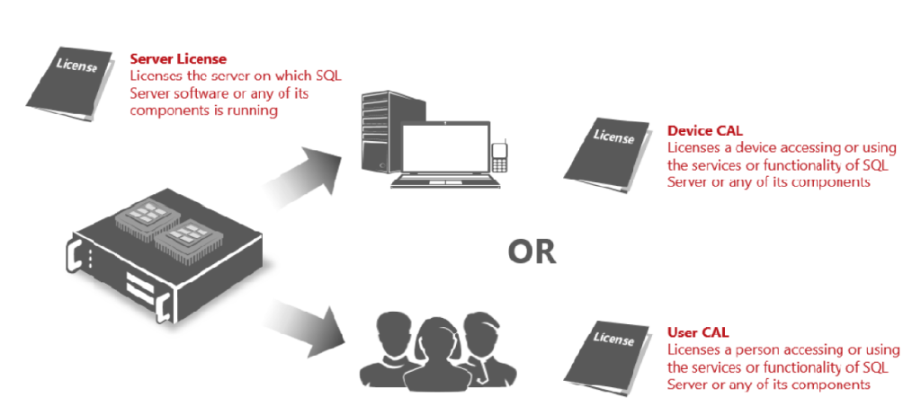

*Source: Microsoft SQL Server 2014 Licensing Guide*

### **Here are the highlights of the Server CAL Model:**

* Each OS running SQL Server 2014, or any components (SSIS, SSAS, SSRS, DQS, MDS) needs to have a server license assigned.
* Number of Instances on the same OS does not require you to buy additional licenses.
* Both Physical and [**Virtual environments**](https://www.faceofit.com/sql-server-licensing-in-a-vm/) are supported.

***Note: Microsoft provides limited support for SQL Server 2014 running anything other than Hyper V.***[***Read More.***](https://support.microsoft.com/en-us/kb/956893)

* Separate Hardware partitions are considered as a different server and need to have a valid license.
* CAL’s need to be of same or higher edition, in order to access SQL Server. For example, SQL Server 2016 CAL can access both 2016 and older versions.
* CPU core count or bitness (32 bit & 64 bit) is not applicable to Server/CAL/Device-based licensing method.
* If you do not have a proper count of end users and devices, (Web App accessed anonymously) then Server/CAL license is invalid.

### Here is the list of applications which are exempted from any type of SQL Server Licensing:

* Client Quality Connectivity
* Client Tools Backwards Compatibility
* Client Tools Connectivity
* Client Tools SDK
* Data Quality Client
* Distributed Replay Client
* Documentation Components
* Management Tools – Basic
* Management Tools – Complete
* Reporting Services Add-in for SharePoint Products
* SQL Client Connectivity SDK

All the components mentioned above are a part of the “**Additional Software**” and you find the reference in the [**Product User Rights**](https://www.microsoft.com/en-in/Licensing/product-licensing/products.aspx) (PUR) document.

# SQL Server 2014 : Licensing In A Virtual Machine

<https://www.faceofit.com/sql-server-licensing-in-a-vm/>

### SQL Server 2014 : Licensing in a Virtual Machine

SQL Server Licensing in a Virtual Machine can be a difficult thing to understand. You need to thoroughly understand the [types of licensing available,](https://www.faceofit.com/sql-server-2014-licensing/) i.e. [Server/Core&Device](https://www.faceofit.com/sql-server-2014-server-cal-licensing/) CAL or [Core-Based licensing](https://www.faceofit.com/sql-server-2014-core-licensing/). Once you understand the basics of Microsoft SQL Server licensing, you can easily understand how to license it in a Virtual Machine (VM) environment. More than 60% of the current SQL Server deployments are in the Virtual environments, and Microsoft expanded virtualization rights, options and benefits to provide greater flexibility for customers deploying in virtual environments.

### In order to License SQL Server in a virtual machine, you have 2 options:

* License the VM running SQL Server software following either the [Server/Core&Device](https://www.faceofit.com/sql-server-2014-server-cal-licensing/) CAL or [Core-Based licensing](https://www.faceofit.com/sql-server-2014-core-licensing/) based licensing model.
* License the Physical server with SQL Server Enterprise & [Software Assurance](https://www.microsoft.com/en-in/Licensing/licensing-programs/software-assurance-default.aspx) in order to be able to license unlimited SQL Server running on the VM’s on the same physical server.

***Buying Software Assurance with SQL Server gives you License mobility rights, VM Rights and Upgrade options to the next version of SQL Server.***

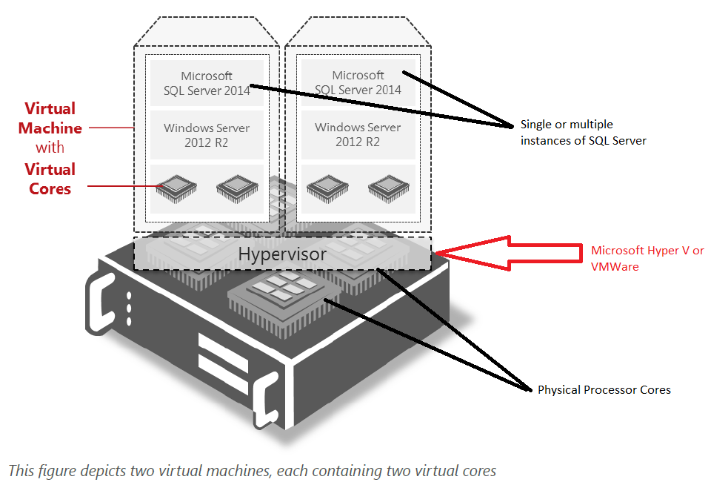

### Licensing Virtual Machines Using the [Per Core Licensing Model](https://www.faceofit.com/sql-server-2014-core-licensing/)

* You need to buy a core license for each virtual processor or a virtual thread(Intel HTT) allocated to the VM.
* You need to buy minimum of a four core license per VM.
* Core factor is not applicable in this method.

Note: You can only license individual VMs for SQL Server 2014 Standard Edition for customers who are running the software in a virtualized environment under the [Per Core model](https://www.faceofit.com/sql-server-2014-core-licensing/).

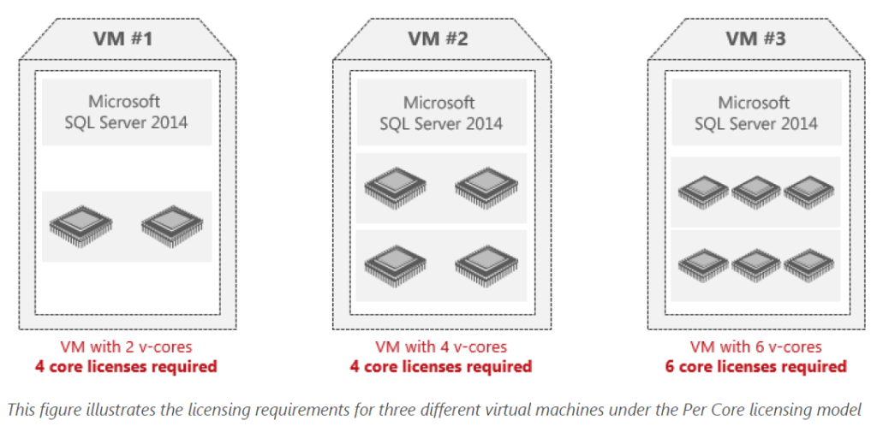

*Source: Microsoft Licensing Guide for SQL 2014*

### Licensing Virtual Machines Using the [Server+CAL Licensing Model](https://www.faceofit.com/sql-server-2014-server-cal-licensing/)

* You need to buy one server license for each VM running SQL Server software, regardless of the number of virtual processors allocated to the VM.
* CALS needs to be purchased for each client connections, connecting directly or indirectly.

***Only available for SQL Server 2014 Standard and Business Intelligence editions.***

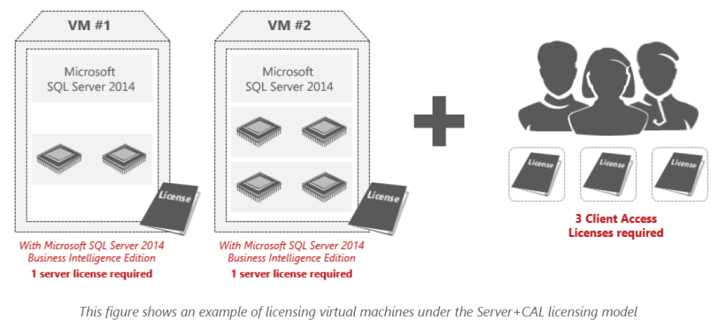

*Source: Microsoft Licensing Guide for SQL 2014*

### **Licensing SQL Server 2014 for High Availability**

<https://www.faceofit.com/licensing-sql-server-2014-for-high-availability/>

Today, more and more SQL Server’s are being deployed in a High availability scenario,  using various technologies available, such as Database Mirroring, Log shipping, Hardware Clustering, Replication or Always On availability groups. In some cases, SQL Server’s are being [deployed on a Virtual Machine](https://www.faceofit.com/sql-server-licensing-in-a-vm/), which in itself is highly available.

Let’s talk about the various scenario’s in HA & DR with SQL Server and how to properly license them.

You need to buy **Software Assurance** for all SQL Server’s which needs to have a “Warm” passive server for failover purposes. The SA (Software Assurance) benefit will ensure “**License Mobility Rights**” so that you do not need to buy additional licenses for the failover partner.

***Note: You cannot run any workloads(Reporting, Querying etc.) on the secondary server. If you do, you need to “Fully” license the second SQL Server. Only Standby servers are supported.***

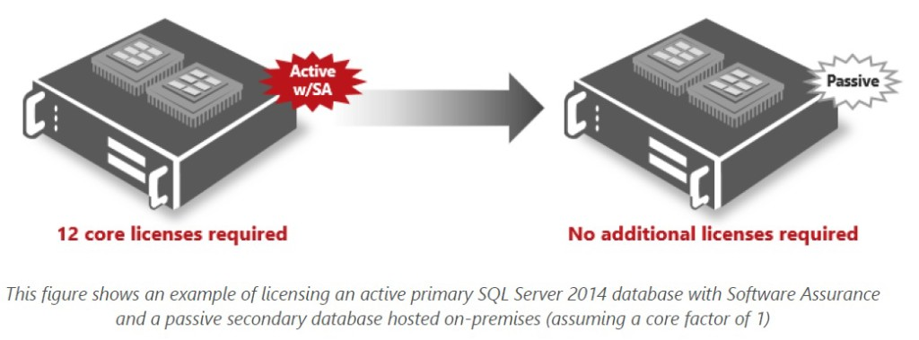

***Source: Microsoft Licensing Guide for SQL 2014***

In the following scenario, One location is covered under the SA benefit. However, since there are 2 secondaries, you need to purchase the required number of licenses for maintaining two DR sites.

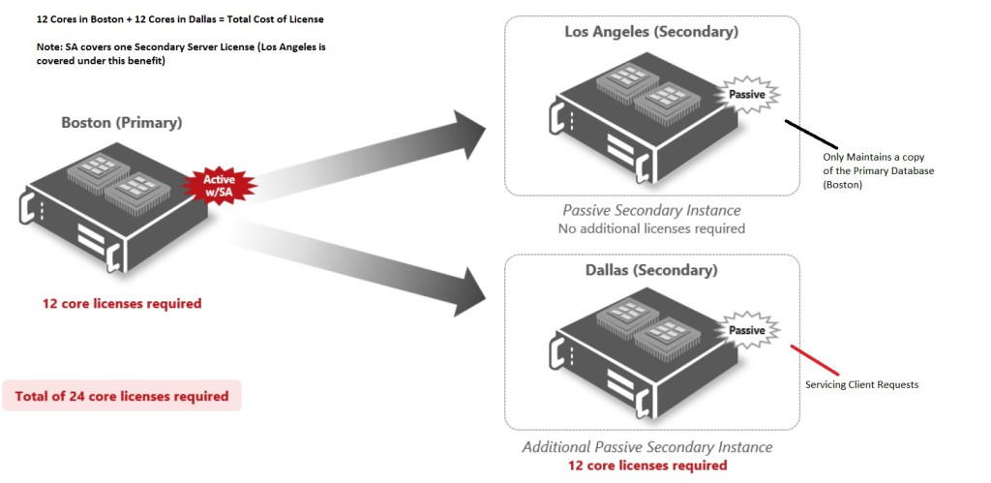

*Source: Microsoft Licensing Guide for SQL 2014*

### **Licensing SQL Server 2014 under the**[**Per Core model**](https://www.faceofit.com/sql-server-2014-core-licensing/)**:**

* The Server which has more CPU Cores needs to be covered under the [Core based licensing method](https://www.faceofit.com/sql-server-2014-core-licensing/).
* If your primary server has 6 core, and the secondary passive site has 8, you need to buy 8 licenses with Software assurance to cover both the installations.
* In case of a failover, the License is dynamically assigned to the secondary server under the “License Mobility Rights”
* In case of Always On Availability groups, all SQL Servers servicing active server workloads needs to be fully licensed.
* ***For Always On Availability Groups, if the Secondaries are using “Read Intent”, “Read-Only” or “Backup Server”, then they need to be fully licensed.***